OudhTrade
Master Database Design
Project document — database standards and data model for all modules
Document details
Company | MRIDA INFRA AND PLANTATIONS LLP
Product | OudhTrade — oudhtrade.com
Document | Master Database Design
Scope | All 20 modules; releases R1, R2 and R3
Readers | Tech lead, backend developers, DBA, QA, product owner
Related documents | PRD · HLD · module database designs (M01-5 … M20-5) · Master Database Diagrams (draw.io)
Owner | Tech lead [TBC: name]
Decision owner | T. Satish Reddy, CEO & Founder
Status | Draft for review — 24 September 2026
Classification | Confidential — for partners and the OudhTrade team

Contents
1. About This Document 3
1.1 Purpose 3
1.2 How it works with the module documents 3
1.3 Diagram key 3
2. Design Principles 3
3. Decisions Taken 4
4. Standards 5
4.1 Naming 5
4.2 IDs and public numbers (D4) 5
4.3 Standard columns (D10, D9) 6
4.4 Data types 6
4.5 Reference data and versions 7
5. Schemas and Ownership 7
6. Rules Between Modules 9
6.1 Shared links 9
7. Core Marketplace Model 10
7.1 People and businesses (D1) 10
7.2 Listings: details, history, languages and location 11
7.3 Agarwood traceability (D11) 12
7.4 Trade flow 12
8. Privacy and Security 13
8.1 Where personal data lives 13
8.2 Encryption and masking 13
8.3 Account closure and anonymisation 13
8.4 Database users and access (D12) 14
9. Performance and Growth 14
9.1 Indicative year-1 volumes 14
9.2 Large tables and partitioning (D8) 14
9.3 Indexes 15
9.4 Summary tables and counters 15
9.5 Two people editing at once (D9) 15
9.6 What is not stored in PostgreSQL (D7) 15
10. Changing the Database Safely 15
11. Planned Tables by Module 16
11.1 M01 Platform Foundation — platform (final) 16
11.2 M02 Identity & Security — identity (final) 16
11.3 M03 Roles, Profiles & Verification — profile (final) 17
11.4 M04 Taxonomy & Compliance Rules — taxonomy 19
11.5 M05 Listings — listing 19
11.6 M06 Origin & Trade Documents — origin 20
11.7 M07 Search & Discovery — search 20
11.8 M08 Requirements & Buy Leads — demand 20
11.9 M09 Messaging & Quotations — messaging 20
11.10 M10 Reviews & Trust — trust 21
11.11 M11 Monetisation — billing 21
11.12 M12 Moderation & Compliance Ops — moderation 21
11.13 M13 to M18 22
12. Module Database Checklist 22
13. Open Items 22

1. About This Document

1.1 Purpose
This is the single rule book for the OudhTrade database. It sets the standards every module follows, the way modules link to each other, the core marketplace data model, and the planned tables of all 20 modules. It is written for a global, listing-only agarwood marketplace that must stay simple to build, easy to maintain and flexible to change.

1.2 How it works with the module documents
Document | Holds
Master Database Design (this document) | Standards, principles, decisions, schema map, rules between modules, core model, privacy, growth, change rules, planned tables of all modules, checklist
Module database design (M0x-5) | Full columns, indexes, detailed diagrams and module-specific rules of that module’s tables
HLD | Hosting, backups, the warm standby in Hyderabad, recovery targets (HLD 5.2) and sizing of the database servers; the event catalogue (Appendix B)

Each fact lives in one place. After every module is designed, the sync step updates Section 11 of this document (planned names become final). Modules 1 and 2 are already final.

1.3 Diagram key
Mark | Meaning
PK / FK | Primary key (unique ID of a row) / foreign key (link to a table of the same module, checked by the database)
ref | ID of a record owned by another module; not checked by the database
Brown table | Table of the module the diagram is about (or, in overview diagrams, any table with its module shown)
Grey dashed table | Table of another module (only linked columns shown)
Two short bars · Circle + bar | Exactly one · Zero or one
Circle + crow’s foot · Bar + crow’s foot | Zero or many · One or many
Dashed line | Reference to another module or match by value (no database check)
Overview diagrams | Show only one (bar) and many (crow’s foot)

2. Design Principles
The design follows the practice of mature listing marketplaces: one well-organised relational database, strict ownership, flexible product details and no clever tricks that only one person understands.
Do | Avoid | Why
One PostgreSQL database, one schema per module | A separate database per module | Clear ownership, simple operations, one backup
Common fields as columns; category-specific fields in one JSON column checked against Module 4 | EAV tables (one row per attribute value) | EAV is slow and hard to query; JSON stays simple and flexible
Status as text with an allowed-values check | PostgreSQL enum types | Enums are hard to change
Business rules in application code | Heavy triggers and stored procedures | Easier to read, test and change
Pre-calculated summary tables for dashboards and counts | Counting live on every page | Fast pages as data grows
Search in Typesense, events in the analytics store, files in S3 | Using the main database for everything | Keeps the main database small and fast
Link other modules by ID only | Joins and foreign keys across modules | Modules stay independent and can be split later
Keep history as snapshots where evidence matters | Overwriting what a buyer saw | Disputes, scam reports and legal orders need proof
Add first, remove later (safe migrations) | Renaming or dropping live columns in one step | No downtime, no broken releases

3. Decisions Taken
# | Topic | Decision
D1 | Business accounts | Designed for teams: a person (account) acts for a profile (business or individual) as a member with a role. V1: one account = one profile = one member. Team members come later; the tables are ready.
D2 | Product details | Common fields as columns; category-specific fields in a JSON column checked against Module 4 attribute definitions; a field becomes a column only if heavily filtered.
D3 | Listing history | A full snapshot is saved each time a listing is published or changed; conversations record the version the buyer saw.
D4 | Public numbers | Hidden UUIDs inside; separate readable numbers outside (listing #10234, invoice OT/2026-27/000123).
D5 | Location | Country, region (ISO), district (India LGD code), city and optional coordinates; no map database in V1.
D6 | Other-language content | Original text stored with its language; translations in separate tables.
D7 | Page views, searches, clicks | Not in PostgreSQL; sent to the analytics store; only daily totals come back.
D8 | Very large tables | Split by month (partitioning) from day one.
D9 | Two people editing at once | Version number on people-edited records; a stale save is stopped with “please reload”.
D10 | Who changed a row | Standard columns created_at / created_by / updated_at / updated_by; sensitive detail in the audit log.
D11 | Agarwood traceability | Lot / batch model reserved now (tree → harvest → chips → oil), detailed in Module 6.
D12 | Security inside the database | Permissions in the application; separate database users for runtime, migrations and read-only reporting; no row-level security in V1.

4. Standards

4.1 Naming
Item | Rule | Example
Schema | Module name, one lower-case word | platform, identity, listing
Table | snake_case, plural noun; avoid reserved words | listings, trade_documents, payment_orders (not orders)
Column | snake_case, singular; no abbreviations except id, no, qty | display_name, moq_qty
Link column | <table in singular>_id; add a role word when needed | profile_id, owner_profile_id
Time / date | …_at = timestamp with time zone; …_on = calendar date | published_at, harvest_on
Yes / no | is_… or has_… | is_cover, has_sample
Public number | …_no | listing_no, invoice_no
Money | …_amount or price_… with a currency column next to it | price_min, currency
Constraints and indexes | pk_, fk_, ux_ (unique), ck_ (check), ix_ (index) + table + columns | ux_profiles_store_name

4.2 IDs and public numbers (D4)
- Internal ID: `id uuid`, version 7 (time-ordered), created by the application. Never shown to users.
- Append-only logs that nothing else points to (audit log, outbox, jobs, delivery events) use `bigint` identity.
- Version-numbered records that staff refer to by number (e.g. `platform.config_versions`, `taxonomy.taxonomy_versions`) may use a simple running number (`int`) as their ID — “settings version 42”.
- Public numbers are separate columns from a sequence; never reused; gaps allowed — except invoices.
- Exception — reference data may use a natural key instead of a UUID (for example unit code, ISO country code, old page path).
Record | Column | Shown as
Listing | listing_no | #10234 (also in the page address)
Requirement | requirement_no | REQ-20451
Conversation | thread_no | T-50317
Quotation | quote_no | Q-80122 (version 2)
Trade | trade_no | TR-3301
Lot / batch | lot_no | LOT-7788
Verification or moderation case | case_no | C-11045
Grievance / legal order | grievance_no / order_no | G-2026-00031 / LO-2026-0007
Payment order | payment_order_no | PO-900123
Invoice / credit note | invoice_no / credit_note_no | OT/2026-27/000123 · OTCN/2026-27/000045 — gapless per financial year, at most 16 characters (GST)

4.3 Standard columns (D10, D9)
Column | Type | On which tables
id | uuid v7 | Every main table
created_at / created_by | timestamptz / uuid | Every table (append-only tables: created_at only)
updated_at / updated_by | timestamptz / uuid | Tables whose rows change
row_version | int | Tables edited by people (listings, profiles, requirements, plans, cases…) — D9
status | text + check | Tables with a life cycle
active or retired_at | boolean / timestamptz | Reference data (retire, never delete)
anonymised_at | timestamptz | Tables with personal data about a person

`created_by` / `updated_by` hold an account, staff or fixed system ID (one per job type). The full before-and-after detail of sensitive actions is kept only in the audit log (M01).

4.4 Data types
Kind of data | Type | Rule
Money and prices | numeric(16,2) + currency char(3) | Never floating point; ISO 4217 codes (INR, USD); converted to paise / cents only inside the payment-gateway adapter
AI call costs | numeric(16,6) + currency char(3) | Only for platform.ai_requests and ai_budgets, because one AI call can cost a fraction of a cent
Unit prices | numeric(16,2) per metric or count unit | Traditional units (tola, mithqal…) are display helpers only (Legal Metrology decision, M01)
Quantities | numeric(16,3) + unit_code | Unit from the Module 1 unit list
Exchange rates / scores | numeric(18,8) / numeric(5,2)
Time | timestamptz (stored in UTC) | Shown in the user’s time zone; calendar dates as date
Text | text + length check where needed | No varchar(n); e.g. listing title ≤ 120 characters
Status and types | text + check (allowed values) | No enum types
Yes / no | boolean not null with default
Country / currency / language | char(2) ISO 3166-1 / char(3) ISO 4217 / text (en, ar, hi, as, bn, zh-Hant, ja)
Region / district | text — ISO 3166-2 (IN-AS) / India LGD district code | Other countries: region only unless needed
Phone / email | text — international format (+91…) / lower-case
Coordinates | numeric(9,6) | Rounded on public pages
Flexible data | jsonb | Only for product attributes, snapshots, settings and provider payloads
Encrypted values | bytea + hash or last-4 column for lookup | Government ID numbers, sensitive document numbers, photo location

4.5 Reference data and versions
- Reference data (units, countries, taxonomy, plans, legal documents, templates) is versioned and retired, never deleted.
- Records keep the version they used: a listing keeps `taxonomy_version`, an acceptance keeps the legal-document version, an invoice keeps a snapshot of plan and price.
- Production reference data changes through the Configuration Console (M16) with approval — not by hand-written SQL.

5. Schemas and Ownership
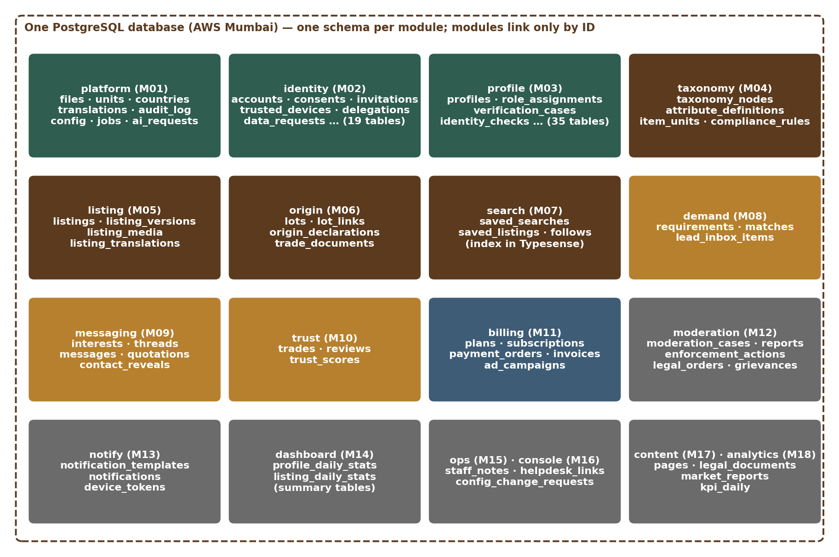
Figure 1 — Schemas in the OudhTrade database
Module | Schema | Owns
M01 Platform Foundation | platform | Files, units, countries, translations, addresses, audit log, settings, rate limits, events, jobs, retention, cookie consent, AI gateway, idempotency keys, reserved names, holiday calendar
M02 Identity & Security | identity | Accounts, staff users, legal acceptances, consents, account states, invitations, Google / Apple links, trusted devices, security history, recovery, contact changes, recycled-number reclaims, delegations, nominees, data requests, risk flags, partner and AI-agent access
M03 Roles, Profiles & Verification | profile | Profiles, members, roles and role changes, business details and registrations, authorised persons, identity checks, verification cases and documents, enhanced checks, badges and badge types, farm profiles and visits, FPO memberships, supply declarations, lab accreditations, field agents, partners, profile extras, drafts and setup reminders
M04 Taxonomy & Compliance Rules | taxonomy | Categories and items, attributes, allowed units, role permissions, compliance rules
M05 Listings | listing | Listings, versions, media, translations, Opportunity details, bulk uploads
M06 Origin & Trade Documents | origin | Lots, lot links, origin declarations, document library, document requests
M07 Search & Discovery | search | Saved searches, saved listings, follows, listing embeddings (the search index is in Typesense)
M08 Requirements & Buy Leads | demand | Requirements, matches, lead inbox
M09 Messaging & Quotations | messaging | Interests, threads, messages, quotations, contact reveals, blocks
M10 Reviews & Trust | trust | Trades, reviews, trust scores
M11 Monetisation | billing | Plans, subscriptions, usage, payments, invoices, coupons, ad campaigns
M12 Moderation & Compliance Ops | moderation | Cases, reports, strikes, enforcement, legal orders, grievances, banned terms
M13 Notifications | notify | Templates, notifications, preferences, delivery events, device tokens
M14 Dashboards | dashboard | Summary tables for seller, buyer and farmer dashboards
M15 Admin: Operations Console | ops | Staff notes, helpdesk links
M16 Admin: Configuration Console | console | Configuration change requests (published settings live in platform)
M17 Content & Legal | content | Pages and guides, legal documents, market reports, FAQs
M18 Analytics & Monitoring | analytics | Daily KPI and funnel totals (raw events outside PostgreSQL)
M19 Mobile Apps | — | No tables; apps use the same API (push device tokens are in notify)
M20 Testing & Go-Live | — | No production tables; test data sets on staging only

Each module’s code reads and writes only its own schema. An automated architecture check in the build pipeline fails the build if code queries another module’s schema.
A separate reporting schema holds only documented, read-only views for dashboards and analytics (no tables). The architecture check allows any module’s reporting job to read these views. Keycloak is not in this database: it has its own small RDS PostgreSQL instance (Section 9.6).

6. Rules Between Modules
- ID only: a module stores the ID of another module’s record (`ref`). There are no database foreign keys across schemas.
- Ask, don’t join: a module gets another module’s data through that module’s interface, never by joining its tables. Exceptions: the read-only reporting user and the dashboard and analytics jobs, which read the documented views in the reporting schema (in R1 on the main database with query time limits; from R2 on the read replica in Mumbai).
- Events keep data in step: important changes publish events through the outbox (e.g. `account.closed`, `listing.removed`, `profile.verified`, `profile.renamed`); other modules react and clean up their own data. Event names come from the event catalogue in HLD Appendix B.
- No deleting other modules’ data: a module asks through an interface or reacts to an event.
- Copies are the exception: copying another module’s data (e.g. a seller name) into a table is allowed only for speed, must be marked as a copy and refreshed by events. Prefer the search index for display copies.

6.1 Shared links
A shared link is a “type” column plus an “ID” column that can point to records of different modules — for example `platform.files.attached_entity_type / attached_entity_id`. The database cannot check such a link, so it is allowed only for shared services: file attachments, page addresses, moderation subjects, document links, audit-log targets, legal holds and staff notes. Every shared link must follow these rules:
- Allowed types only — the type column accepts a listed set of values (database check).
- Owner sets the link — only the owning module creates the link, through the shared service’s interface, which checks the record exists.
- Events keep it clean — when a record is removed, the shared service detaches or retires its links.
- Nightly check — a scheduled job reports links that point to missing records; staff fix them after review.
- Index — each (type, ID) pair is indexed.

7. Core Marketplace Model

7.1 People and businesses (D1)
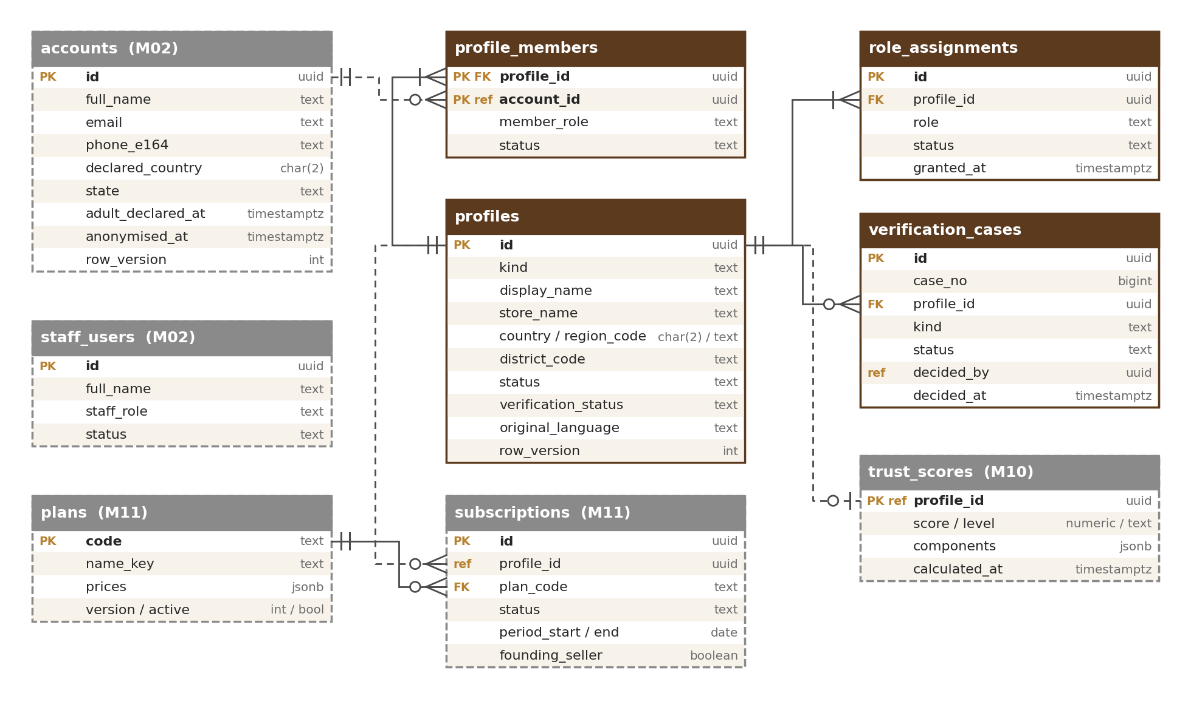
Figure 2 — People, businesses and plans
- Account (M02) = one person who signs in. Profile (M03) = the face on the marketplace: kind business (company, seller, nursery, inoculation provider, business buyer) or individual (farmer, individual buyer).
- Members: an account acts for a profile as a member with a role — owner, admin, sales or viewer. In V1 one account = one profile = one member; teams can be switched on later without changing tables.
- Roles belong to the profile (buyer, seller, company, nursery, inoculation provider, farmer). Business roles only on business profiles; farmer only on individual profiles.
- Ownership: listings, requirements, conversations, subscriptions, verification and trust scores belong to the profile; each message and action also records the account that did it.
- Staff are separate (`staff_users`, own sign-in realm) and never mixed with accounts. Field agents act for farmers only through a time-limited, farmer-approved delegation (`identity.delegations`, M02).

7.2 Listings: details, history, languages and location
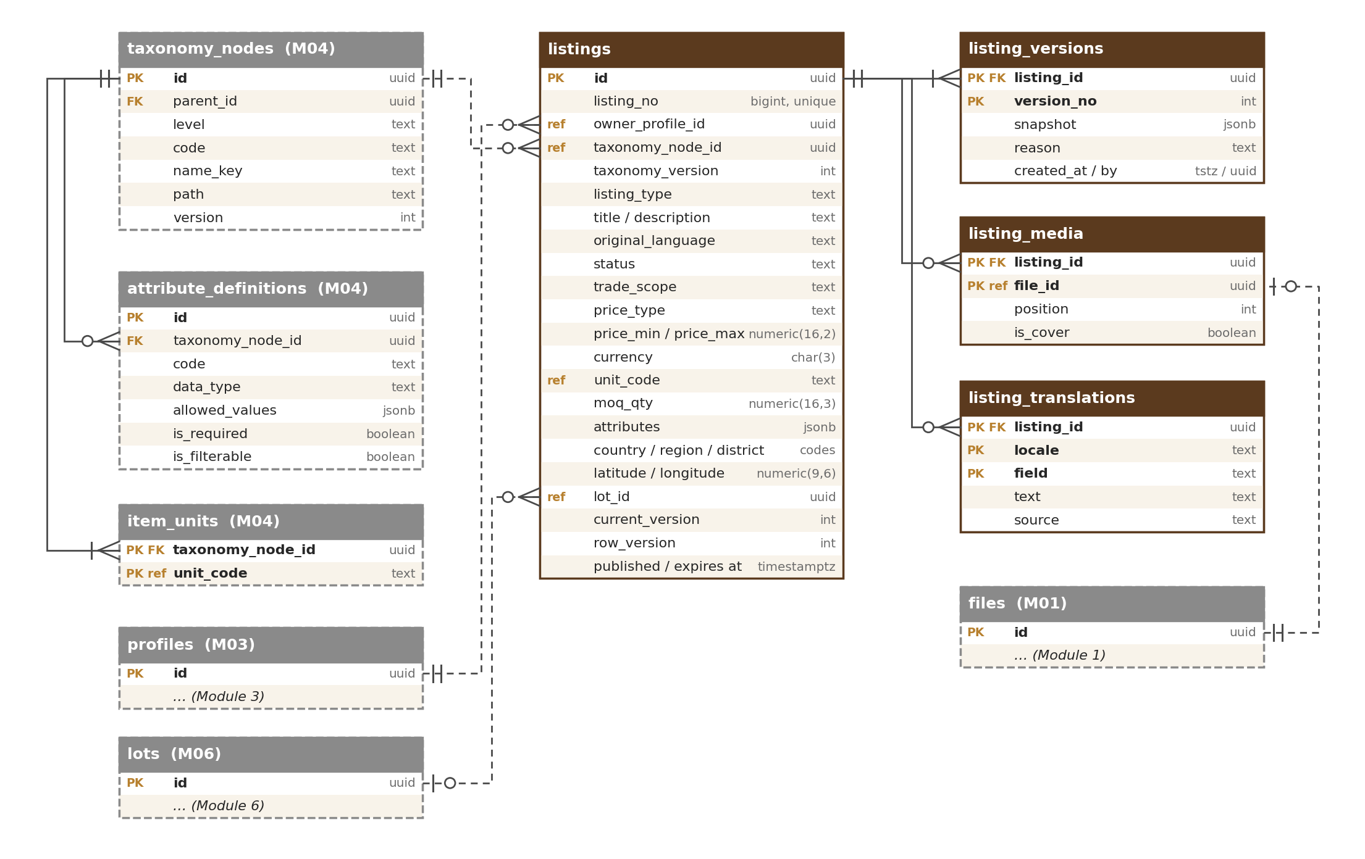
Figure 3 — Listings with attributes, versions, media and translations
Topic | Design
Product details (D2) | Common fields are columns (type, status, price, currency, unit, minimum order, trade scope, location). Category-specific fields are in `attributes` (JSON), e.g. `{"sinking_class": "semi_sinking", "resin_level": "high", "age_years": 12}` for chips or `{"purity": "pure", "distillation": "hydro"}` for oil. Keys and value types are checked against Module 4 `attribute_definitions` for the listing’s item and taxonomy version; unknown keys are rejected. Filterable attributes are copied to the search index. A field is promoted to a real column only if the database filters on it heavily.
History (D3) | Each publish or change after publishing writes a full snapshot to `listing_versions`. The listing row is the current state. Interests and conversations record the version the buyer saw. The same pattern is used for requirements, quotations (each counter-offer is a new version) and legal documents.
Languages (D6) | Seller text is stored as written with `original_language`; translations (machine or human, with source) are in `listing_translations`. The same pattern applies to profiles and requirements. Interface text uses the Module 1 translation keys instead.
Location (D5) | country, region_code (ISO, e.g. IN-AS), district_code (India LGD), city, and optional latitude / longitude — rounded on public pages for privacy. No map database in V1; “near me” later via search-engine geo features or a map extension.

7.3 Agarwood traceability (D11)
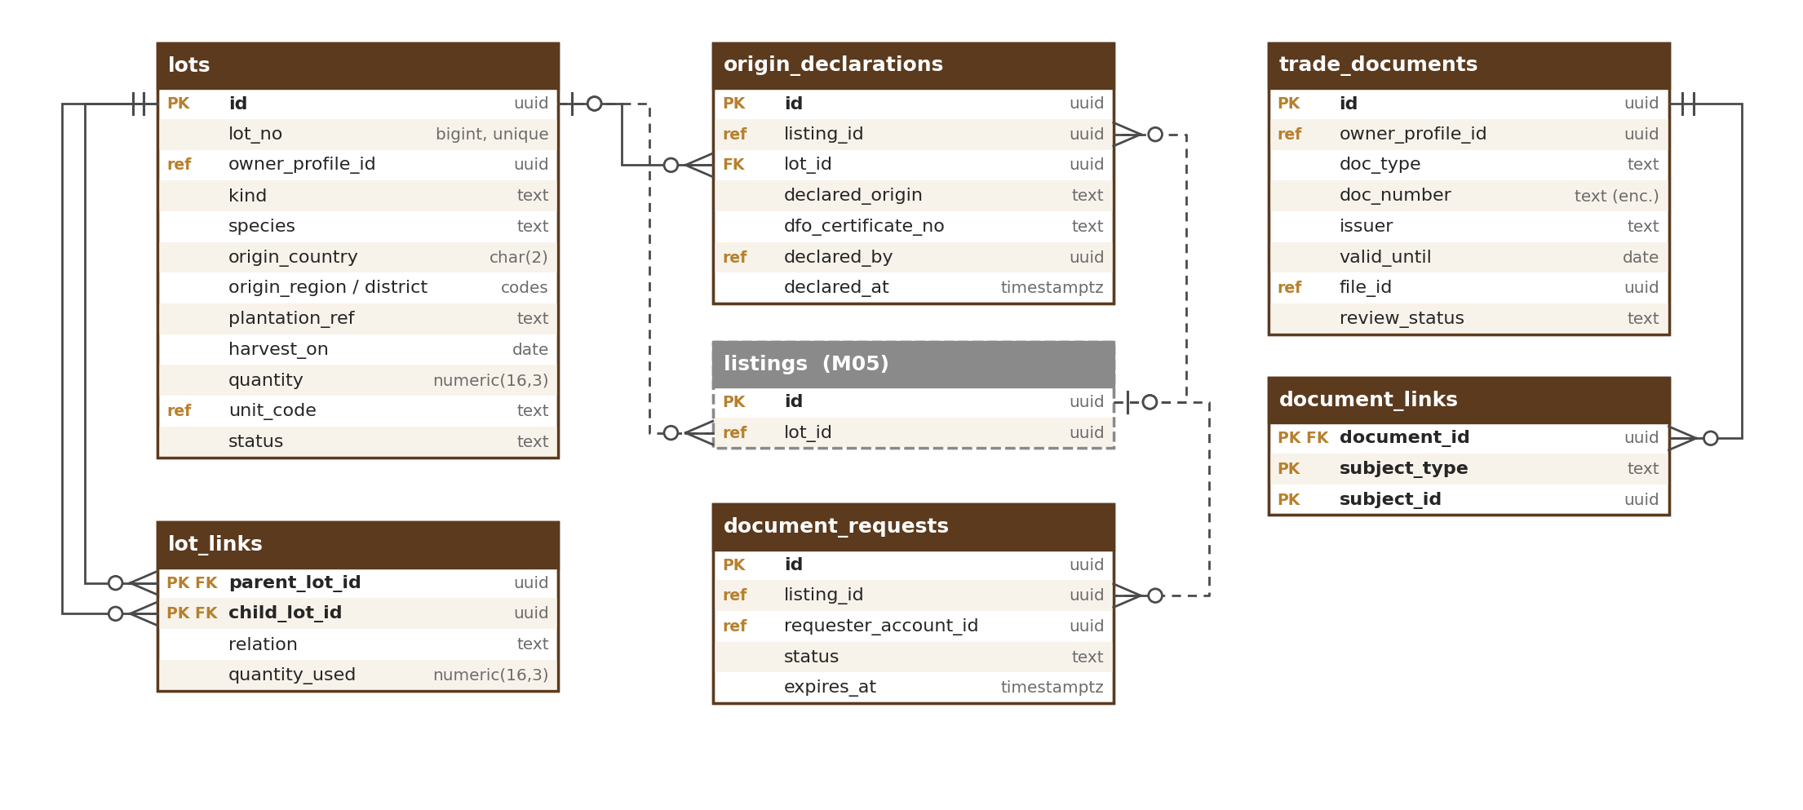
Figure 4 — Lots, origin declarations and trade documents
- Lot = a quantity of agarwood material with a known origin: plantation, harvest, raw wood, chips, powder or oil batch (with species, origin and quantity).
- Lot links build the chain: oil batch *distilled from* chips lot, chips *cut from* harvest, harvest *harvested from* plantation.
- Origin declarations record what the seller declares for a listing or lot (e.g. plantation-grown) and the DFO certificate number for export.
- Trade documents are the document library (DFO Certificate of Legal Possession, CITES permit, lab report, IEC, FSSAI, GST…) with number, issuer and validity; document links say which listing, lot or profile a document supports; document requests track buyers asking to see one.
- In V1 lots are optional; Module 6 decides which categories need them. The structure already supports full chains for exports, Forest Department and WCCB cooperation, and batch-level lab reports.

7.4 Trade flow
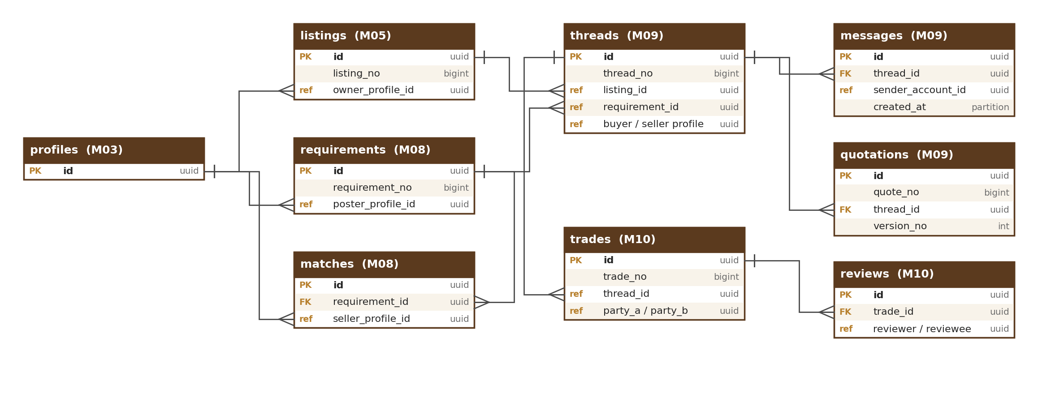
Figure 5 — From listing or requirement to trade and review
A buyer reaches a seller through a listing or a requirement (via matches). R1 records interests; from R2 a thread holds messages and versioned quotations. When both sides confirm (or the other side does not reply within 7 days after 2 reminders — shown as “confirmed (no reply)”), a trade is recorded, which allows reviews that feed the trust score. Every step keeps the IDs of the step before, so the whole path can be traced.

8. Privacy and Security

8.1 Where personal data lives
Personal data is kept in as few tables as possible; all other tables hold only IDs. This makes access control, retention and “delete my data” (DPDP) simpler and safer.
Area | Personal data | Notes
identity.accounts | Name, email, phone, declared / phone / sign-up IP country | Main record of a person; anonymised after the 30-day closure grace
identity.legal_acceptances | Account, time, IP of acceptance | Kept as proof
identity.consents | Consent choices per purpose, notice version, channel | History kept as proof of consent (DPDP)
other identity tables | Invitation contacts, nominee details, device and IP in security history and trusted devices, recovery evidence | Kept only as long as needed (periods in M02-5)
profile tables | Business contacts, addresses, registration numbers, authorised persons, beneficial owners, identity-check results, verification documents, farm-visit photos, consents to third-party checks | Numbers encrypted where sensitive; documents are private files (Restricted); Aadhaar number never stored (last 4 digits only); selfies not kept (result only); rejected or replaced documents deleted after 90 days (M03-5)
origin.trade_documents | Document numbers and files | Private; views logged
messaging tables | Message text, attachments | Retention per schedule; legal hold applies
billing.invoices | Buyer name, GSTIN, address | Kept 8 years by law
moderation tables | Reporter and complainant details | Restricted to moderation staff
notify.notifications | Email / phone destination | Short retention
platform tables | Audit actor and IP, consent choices, preferences, photo location | See M01-5

8.2 Encryption and masking
- All data is encrypted at rest (AWS KMS) and in transit (TLS).
- Extra field-level encryption for government ID numbers, sensitive document numbers and photo location; a hash or last-4 column allows lookup without decrypting.
- Personal data is masked in logs and in audit before / after values; test sites never hold real personal data.

8.3 Account closure and anonymisation
- When the 30-day closure grace period set in Module 2 ends, Module 2 publishes `account.closed`; each module then runs its own anonymiser at once.
- The account row keeps its ID but loses name, email and phone (`anonymised_at` set); reviews show “Former member”; listings are removed.
- Records the law requires (invoices, audit log, legal holds) are kept; the retention schedule (M01) decides the rest.

8.4 Database users and access (D12)
Database user | Can do | Used by
app_runtime | Read / write data in module schemas; no table changes; audit log insert and read only | Core API and workers
app_migrator | Create and change tables | Pipeline migration step only
app_readonly | Read the reporting views (personal-data columns hidden) — in R1 on the main database with query time limits, from R2 on the read replica | Reporting, dashboards jobs
Break-glass admin | Full access for emergencies, except platform audit tables: there only INSERT and SELECT (no update or delete) | Named person, time-limited, approved; each break-glass session is logged to a separate locked store

Permissions for users and staff are checked in the application (HLD). Staff never query production for daily work; they use the Admin app.

9. Performance and Growth

9.1 Indicative year-1 volumes
Data | Rows (year 1) | Note
Accounts / profiles | ≈ 50,000 / 60,000 | HLD sizing
Listings / listing versions | ≈ 100,000 / 400,000
Files (with variants) | ≈ 1.2 million | Files themselves in S3
Messages | ≈ 3–5 million | Partitioned
Notifications | ≈ 5–10 million | Partitioned; short retention
Audit log | ≈ 5 million | Partitioned; 13 months in PostgreSQL, then only in the locked archive (7 years in total)
Outbox events | ≈ 10 million | Cleaned after delivery
Page views, searches, clicks | Not stored in PostgreSQL | Analytics store (D7)

Figures are estimates for design; load tests before R2 confirm them (HLD).

9.2 Large tables and partitioning (D8)
- Split by month from day one: messages, notifications, delivery events, payment events, audit log, outbox events, trust-score history, AI requests.
- The partition key is the table’s own time column (for example `created_at` or `occurred_at`) and is included in the primary key (PostgreSQL rule).
- Future months are created automatically; old months are archived to S3 or dropped as the retention schedule allows.
- The audit log is kept 13 months in PostgreSQL; older months are only in the locked archive in S3 (7 years in total).
- `processed_events` rows (event handlers’ “already done” records) older than 30 days are deleted.

9.3 Indexes
- Every link column (FK or ref) is indexed.
- Composite indexes match real screens, e.g. (owner_profile_id, status, updated_at) for “My listings”.
- Partial indexes for hot subsets, e.g. live listings only.
- Unique constraints enforce rules (one store name, one active subscription per profile, one idempotency key per payment).
- JSON (GIN) indexes only when a query proves the need; a text-search column on listings supports the database search fallback (HLD).
- No index without a query that needs it; slow queries reviewed monthly.

9.4 Summary tables and counters
Views, enquiries, response rates and similar numbers are not counted by updating the listing row on every event (that blocks busy rows). They are calculated by jobs into summary tables (M14 dashboards, M18 KPIs) from events and the analytics store. Trust scores are recalculated by jobs.

9.5 Two people editing at once (D9)
People-edited tables carry `row_version`. An update succeeds only if the version is unchanged (`… WHERE id = ? AND row_version = ?`); otherwise the user sees “This was changed by someone else — please reload”. Payments and webhooks use unique idempotency keys so repeats have no effect.

9.6 What is not stored in PostgreSQL (D7)
Data | Where | Why
Photos, documents, videos | S3 (Module 1 file service) | Large binary files
Search index | Typesense (rebuilt from PostgreSQL) | Fast keyword and meaning search
Page views, searches, clicks, ad impressions | Analytics store [TBC: choice in M18] | Very high volume
Cache, rate-limit counters, chat presence, frequency limits, WebSocket fan-out | Redis | Short-lived
Passwords, OTP, sessions | Keycloak, on its own small RDS PostgreSQL instance with its own backups and database user (not one of the 18 module schemas) | Identity system
Secrets and keys | AWS Secrets Manager / KMS | Security
Application logs | CloudWatch (security logs ≥ 180 days in India) | Operations and CERT-In

10. Changing the Database Safely
- Schema as code: migration scripts in the code repository are the source of truth; each is versioned, reviewed and run by the pipeline as a separate step before deployment. Tool per the team’s technology proposal (e.g. Flyway, Liquibase or framework-native).
- Add first, remove later (expand → migrate → contract): add the new column or table; release code that writes both old and new; fill old rows in small batches; switch reading to the new; remove the old in a later release. Never rename or drop a live column in one step.
- No blocking changes: indexes are created concurrently; large backfills run as background jobs.
- Roll forward: mistakes are fixed with a new migration; point-in-time restore and the warm standby in Hyderabad are for disasters only (HLD 5.2).
- Reference and seed data: kept as versioned data files (units, countries, taxonomy seeds) and loaded by migration or configuration import; later changes go through the Configuration Console.
- Diagrams from the real schema: once built, the pipeline generates table diagrams from the database; the diagrams in module documents are the design reference and are updated at each sync step.
- Test data: staging uses made-up data and the demo data set (M01).

11. Planned Tables by Module
Module 1 is final (33 tables, details in M01-5). Module 2 is final (19 tables, details in M02-5). Module 3 is final (35 tables, details in M03-5). Other names are planned; each module’s database design confirms names and columns and this section is updated at the sync step.

11.1 M01 Platform Foundation — platform (final)
files, file_variants, video_assets, image_blocklist, units, area_unit_factors, translations, user_preferences, trade_terms, countries, country_regions, country_districts, fx_rates, url_slugs, url_redirects, audit_log, config_versions, config_entries, feature_flags, rate_limit_policies, rate_limit_blocks, outbox_events, processed_events, jobs, schedules, retention_policies, legal_holds, cookie_consents, ai_requests, ai_budgets, idempotency_keys, reserved_names, business_holidays.
Table | Purpose
ai_requests | One row per AI call through the AI gateway: module, purpose, provider, model, tokens, cost, data level sent, result status, time (partitioned monthly)
ai_budgets | Monthly AI cost limits per module and purpose, with alert levels
idempotency_keys | Key, account, endpoint, request hash, stored response, expiry (24 h) — makes retried writes safe
reserved_names | Reserved, banned and protected brand names for store names and page addresses
business_holidays | Holiday calendar used by the IST business-hours calculator

11.2 M02 Identity & Security — identity (final)
Keycloak (own database, not in this schema) holds passwords, OTP secrets, authenticator and passkey credentials, backup codes and sessions. accounts also holds declared_country, phone_country, signup_ip_country (the sign-up sanctions check uses all three), email_optional (farmers), last_active_at, dormant_at, state (active, deactivated, dormant, suspended, banned, closed), invited_by / invitation_id, and signup_source (invitation, field_agent, fpo_invitation, seller_link, direct) with referring_profile_id — the seller whose share link was used (M02-5).
Table | Purpose
accounts | One row per person who can sign in (passwords and OTP are in Keycloak)
staff_users | OudhTrade staff (separate sign-in realm)
legal_acceptances | Which version of each required sign-up agreement line each account accepted, when and from where; one row per line: terms, privacy, data_processing_consent, grievance_notice, off_platform_notice, age_declaration
consents | Consent choice per purpose (given or withdrawn) with chosen_at, notice version and channel; five purposes: marketing email, marketing SMS, marketing WhatsApp, personalised promotions, AI-assist on my listings; one row per change, so the history is kept. The analytics cookie consent is in platform.cookie_consents (M01)
account_state_history | Active, deactivated, dormant, suspended, banned, closed — with reason
invitations | Invitation links and codes: who invited whom, single use, 14-day expiry
external_identities | Google and Apple sign-in links to an account
trusted_devices | Devices remembered for 30 days (“remember this device”)
security_events | User-visible sign-in and security history, kept 12 months (security logs ≥ 180 days are also in the log archive)
recovery_requests | Account recovery requests, their checks and waiting periods
contact_changes | Pending phone, email and account-country changes with cooling-off
number_reclaims | Recycled-number reclaim requests, with the 7-day objection window
delegations | Farmer-approved rights for a field agent (scope, 30-day expiry, cancelled)
nominees | Nominee named by a user (DPDP)
data_requests | Data download, correction and deletion requests (DPDP) with timers and status
risk_flags | Account-takeover and ban-evasion signals for staff review
api_clients | Partner and AI-agent clients (R2; secrets in Keycloak)
api_grants | A user’s consent to a partner or AI-agent client (R2)
disposable_email_domains | Admin-managed list of throw-away email domains

11.3 M03 Roles, Profiles & Verification — profile (final)
Table | Purpose
profiles | Business or individual profile shown on the marketplace (storefront): legal name (as on the ID) and trading name, display_name (the farmer’s public name), short_bio (300 characters, public) in addition to the description, billing country, verification state; away_until (date) and away_message (optional, 300 characters, contact details removed) for Away mode, used from R3
profile_members | Accounts that act for a profile, with member role (D1)
role_assignments | Marketplace roles of a profile
role_change_requests | Requests to change role (upgrade paths only, from the setting profile.role_change.paths) with the new role’s documents, decided by Admin
profile_addresses | Registered address, business locations, the farmer’s home village and the buyer’s city (on address_type home), in the country layout; per location: site type, label (site label), landmark, contact_hours (jsonb, public as “Usually available”), photo_file_ids (up to 2) and video_file_id (1) shown after the M01 safety review; village (private) and map pin (private)
profile_translations | Translated profile texts (D6)
business_registrations | GSTIN, PAN, CIN, Udyam (incl. Udyam Assist), IEC (India, sellers who export; DGFT check where possible) and other per-country numbers (encrypted, hashed, shown masked; PAN is never public) with issuing_authority, registry-check result and monthly status check; name_mismatch_note (private, reviewers only)
verification_cases | Each verification request (business, farmer, buyer, enhanced, re-verification, role change) with its state and decision
verification_documents | Documents submitted in a case (files in M01; Restricted; rejected or replaced ones deleted after 90 days), including “Other document” with a name the user types when the type is not in the list; it never replaces a required document or earns a badge alone
badges | The 12 profile badge types (M03-5): Business verified, Verified farmer, Verified buyer, Co-operative / FPO, Women-led enterprise, Founding Seller, Enhanced check passed, Farm visited, Accredited lab, OudhTrade Partner (R2), GST registered, Trusted (R2) — each with an “as of” date; badge_type refers to badge_types. The “Export permitted” listing badge belongs to M05 / M06
badge_types | Reference list of badge types: badge_key, kind (automatic or staff_awarded), name, help text, evidence needed, allowed roles, validity months, where shown, active, version and approval (approved_by, approved_at). Admin can add staff-awarded types with a second approver; automatic types need a code release
field_agents | Field agents (region, partner, status); the farmer’s delegation to an agent is identity.delegations (M02)
partners | Approved partner organisations (OudhTrade Partner programme; organisations whose staff act as field agents)
country_id_rules | Per-country business ID fields: label, format and required groups (India: at least one of GSTIN, CIN, Udyam)
document_checklists | Documents needed per role category and country, with validity rules
authorised_persons | Person who acts for the business: name, designation, relationship to the account
identity_checks | Identity check method, provider and result; Aadhaar last 4 digits only; face-match result; alternative route used
verification_consents | Consent to each third-party check, versioned; six check types: registry lookup, DigiLocker, Aadhaar OTP e-KYC, selfie / face match, bank account check, supplier_document_share (document forgery-check supplier)
enhanced_checks | Enhanced check for Opportunities, land and business sales and big exporters (business selling roles only; farmers do not take it): address proof and an optional bank check with country-specific bank fields (India: automated check, only result and bank name kept; other countries: bank statement or letter for manual review, deleted after review like other check files; only the result and bank name are kept). land_rights_document_id removed: land rights proof is added to the land or plantation listing (M05 / M06)
beneficial_owners | Owners with 25% or more, declared in the enhanced check
sanctions_screenings | Sanctions and PEP name checks: manual weekly batch in R1, automated service from R2
farm_profiles | The farmer’s “Your trees”, optional and self-declared: species (tree type), number of trees (range), tree age (the district shown publicly comes from the farmer’s home address in profile_addresses). Forest-department registration number columns removed: the number is asked on the listing and trade documents (M05 / M06), with the plantation name, place or area, inoculation status and map pin. Land columns removed (tenure_type, land_proof_document_id, land_proof_valid_until): land papers belong to listings (M05 / M06), not farmer onboarding
farm_visits | Field-agent farm-visit report: geo-tagged photo references, tree count and age (basis of “Farm visited”)
agent_quality_checks | Random re-checks (default 10%) of agent- and FPO-confirmed farmers and their outcome
fpo_memberships | Farmers confirmed as members by an FPO or co-operative
supply_declarations | Declared yearly capacity (kg or litres) and source for wood, chips and oil sellers, with review flag
lab_accreditations | NABL or ISO/IEC 17025 certificate and scope checked before a lab is shown as “accredited”
profile_interests | What I buy / what I offer (top-level categories until M04); capacity figures are in service_capabilities
profile_links | Website and social links (website, instagram, facebook, youtube, linkedin, x) with safety-scan result and ownership check (ownership_method meta_tag / file / bio_code, ownership_token_hash, ownership_confirmed_at)
profile_contacts | Private business phone and email (not shown publicly)
compliance_declarations | Signed compliance declaration with agarwood clauses, versioned
name_history | Store (trading) and legal name changes; “Formerly {name}” shown for 90 days
profile_drafts | Per-field drafts of setup forms saved on the server
setup_reminders | Reminders for unfinished setup and waiting documents
service_capabilities | Nursery and Inoculation Provider capability details: techniques, species, coverage areas, service_radius_km (private), capacity_per_month (exact, private; public as a range), trees_treated_total and seedlings_per_year (public as ranges), service notes

11.4 M04 Taxonomy & Compliance Rules — taxonomy
Table | Purpose
taxonomy_versions | Published versions of the taxonomy
taxonomy_nodes | Categories → sub-categories → items (tree)
attribute_definitions | Fields per item: type, allowed values, required, filterable (D2)
item_units | Units allowed per item
role_permissions | Which role may list, post Opportunities or post requirements per item
compliance_rules | Per item and country: documents needed, export allowed, CITES, FSSAI, origin declaration

11.5 M05 Listings — listing
Table | Purpose
listings | Current state of each product, service or Opportunity listing
listing_versions | Snapshot at each publish or change (D3)
listing_media | Photos and video of a listing, order and cover
listing_translations | Translated listing texts (D6)
listing_status_history | Status changes with who and why (expired, removed, restored)
opportunity_details | Opportunity type, legal notice version and review checklist result
bulk_uploads | Spreadsheet uploads and row results

11.6 M06 Origin & Trade Documents — origin
Table | Purpose
lots / lot_links | Lots (plantation, harvest, chips, oil batch…) and the chain between them (D11)
origin_declarations | Seller’s origin declaration per listing or lot, DFO certificate number
trade_documents | Document library with number, issuer, validity and review status; also land and plantation proofs for land, plantation and standing-tree listings (moved from farmer onboarding in M03)
document_links | Which listing, lot or profile a document supports
document_requests / document_shares | Buyer requests to see documents and time-limited access given

11.7 M07 Search & Discovery — search
Table | Purpose
saved_searches | Saved searches with alert settings
saved_listings | Buyer favourites
follows | Follows of sellers or categories
listing_embeddings (planned) | Meaning (vector) embeddings of listings, made through the AI gateway and copied to the search index

11.8 M08 Requirements & Buy Leads — demand
Table | Purpose
requirements / requirement_versions | Buyer requirement posts and their snapshots
requirement_translations | Translated requirement texts
matches | Sellers matched to a requirement, with score and reason
lead_inbox_items | Buy leads per seller: new, viewed, responded, dismissed

11.9 M09 Messaging & Quotations — messaging
Table | Purpose
interests | R1 “Register interest” records (quantity, destination, note)
threads / thread_participants | Conversations between buyer and seller profiles
messages | Messages (partitioned by month)
message_attachments | Files attached to messages
quotations | Quotations; each counter-offer is a new version
contact_reveals | Who revealed whose contact details, when (rate-limited)
user_blocks | Profiles that blocked each other
safety_events | Messages blocked or warned by the safety filter

11.10 M10 Reviews & Trust — trust
Table | Purpose
trades | Trades marked “We traded” and confirmed by both sides, or “confirmed (no reply)” after 7 days and 2 reminders
reviews / review_responses | Double-blind reviews and seller replies
trust_scores / trust_score_history | Current trust score and level; history (partitioned)

11.11 M11 Monetisation — billing
Table | Purpose
plans / plan_features | Plans, prices per currency, allowances (versioned)
subscriptions | Plan of each profile and period
entitlement_usage | Allowance used per profile and period (e.g. videos, lead responses)
coupons / coupon_redemptions | Discount codes and their use
payment_orders / payment_events / refunds | Checkout orders, gateway webhooks (partitioned), refunds
invoices / invoice_lines / credit_notes | GST invoices and credit notes (kept 8 years)
invoice_series | Gapless number counters per financial year
ad_campaigns / ad_placements / ad_daily_stats | Ad Engine campaigns, slots and daily totals

11.12 M12 Moderation & Compliance Ops — moderation
Table | Purpose
moderation_cases / case_events | Review cases with queue, service target timer and history
reports | User reports (scam, wrong category, prohibited content…)
strikes / enforcement_actions | Strikes and actions: warn, hide, suspend, ban
legal_orders | Court and government orders with the 3-hour timer
grievances | Complaints with 24-hour acknowledgement and 7-day resolution tracking
banned_terms | Banned words and claims lists

11.13 M13 to M18
Module — schema | Planned tables
M13 Notifications — notify | notification_templates (versioned per channel and language), notifications (partitioned), notification_preferences, delivery_events (partitioned), device_tokens (R3), suppression_list
M14 Dashboards — dashboard | profile_daily_stats, listing_daily_stats
M15 Operations Console — ops | staff_notes, helpdesk_links
M16 Configuration Console — console | config_change_requests (published values go to platform config tables)
M17 Content & Legal — content | pages / page_versions (CMS and guides), legal_documents (versioned with effective date), market_reports, faqs
M18 Analytics & Monitoring — analytics | kpi_daily, funnel_daily (raw events outside PostgreSQL)
M19 Mobile Apps / M20 Testing | No tables

In total about 173 tables across 18 schemas for V1, plus the reporting schema, which holds only views.

12. Module Database Checklist
Every module database design (M0x-5) must pass this checklist before it is signed off:
# | Check
1 | All tables are in the module’s own schema and follow the naming rules (4.1)
2 | Standard columns (4.3) and data types (4.4) are used
3 | Each table has a purpose, key columns, indexes and allowed status values
4 | Links: FK inside the module; ref across modules; shared links only under Section 6.1
5 | Group diagrams with full notation, plus a diagram of links to other modules
6 | Personal-data tables are listed for the data map (8.1); retention policies registered in M01
7 | Large tables have a volume estimate and a partitioning decision (9.2)
8 | History needs decided (snapshots / versions) and public numbers defined (4.2)
9 | row_version on people-edited tables; idempotency keys where repeats can happen
10 | Events published by the module are listed
11 | Changes follow add-first, remove-later (Section 10)
12 | Section 11 of this document updated at the sync step

13. Open Items
# | Item | Decided in
1 | Analytics store for page views, searches and clicks | M18 tuning
2 | Migration tool and monthly-partition tool | Team technology proposal
3 | Retention period per table | Counsel, before R1
4 | Undo period and anonymisation steps on account closure | M02 tuning
5 | Categories that must use lots | M06 tuning
6 | Team members per business profile, per plan | M03 / M11 tuning

